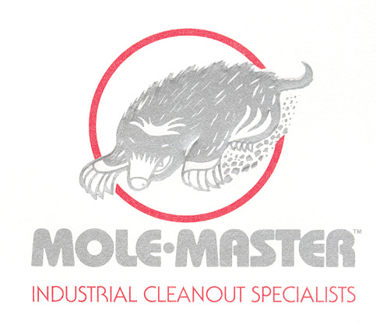
DATE

COMPANY

FACILITY

ADDRESS

CITY STATE ZIP

CONTACT TITLE

DEPARTMENT

PHONE FAX

MOBILE EMAIL

PIPE CLEANOUT QUESTIONNAIRE

Thank you for considering Mole•Master Services Corporation for your pipe cleaning project.
We do offer several options to remove build-up and blockages that reduce flow and decrease productivity. To help us determine the best way to clean and unclog your pipeline, please answer the following questions.

Cleanout Preference Wet/Dry?

Diameter of Pipe:

How many feet of pipe?
How many 45 degree elbows?

What is the pipe made of?
How much room would there be in the front and in the rear of the pipe line?

Are there any type of access openings along the pipeline?

Is the pipeline above or below ground?

How much build-up in the pipe?

How hard is the build-up?
How long has the material been inside the pipe?

What is the material?

Having these questions answered as well as any basic drawing of the line would help us greatly in determining whether Mole•Master Services Corporation could be of assistance for this project.

Pipecleanoutquest

